Account Balance Fetch Api:

api-account-service > Account Response >

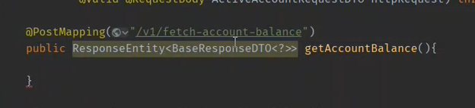

Aese path bhi day saktay magar uppar daydain tw better hai

Second yai k uppar variable banakr neechay pass karday

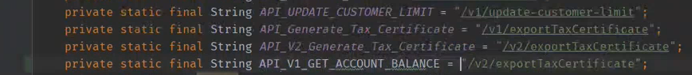

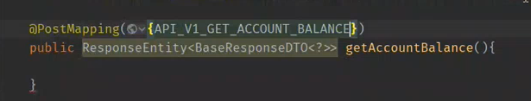

DTO humay Account Service mai milengay saray

Account service > dto > request > v1

Yaha 1 dto create kardengay GetActiveAccountBalanceDto k naam sai

Us dto ko BaseDto sai extend kardengay

BaseRequest mai saari basic cheezain arahi hoiti hai userId channeld device id etc.

Or yai saari cheezain 8762 means gateway par aati hai

Gateway sai further route account par hoti hai

Learn filters

You can learn filter from api-gateway service

Base request kaise find hota hai frond end jab request aati hai wo apne sai JWT token lekar aati hai

Sab sai pehlay security mai jwt filter hai wo chalay ga yai user detail nikal kar aglay filter ko pass on karday ga.

Ab Dto mai base request extend kar user ki detail ajayegi ab humay dto mai kuch cheezain add karni hai jo actual channel rdv ko bhejni hai.

For ex sirf humay account number bhejna hai

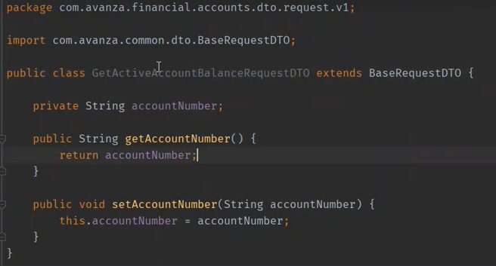

Is k getter setter banadengay.

Ab yai dto or request mai apne get account balance mai add kardunga jo controller abhi banaya tha.



Ab transactional.xml mai jayengay

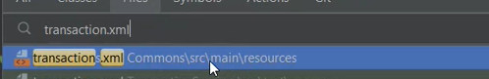

Rdv k sath jitni bhi implementation hoe hai un sb ki mapping hai yaha par

Wahai sai 1 transaction copy kar k uski transaction code or name change kardengay.

Transcation code rdv or hamary beech decide hoga wohi rakhengay hum.

Us k andar wohi parameter add karengay jo dto mai hongay.

Hostkey mai rdv k parameter dalengay.

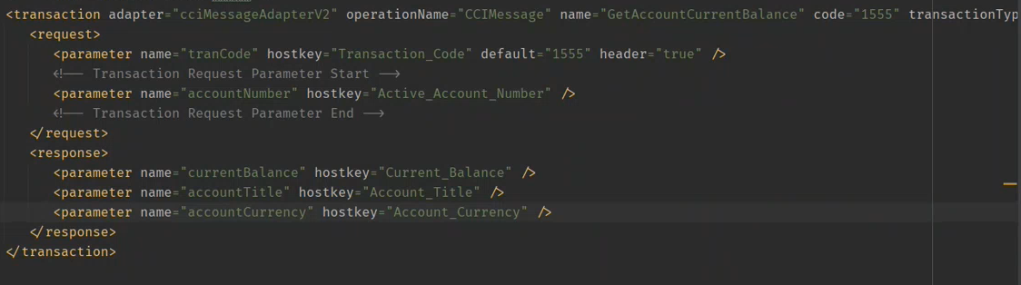

Ab response structure banana paray ga.

Dto k andar response mai jakar banayengay

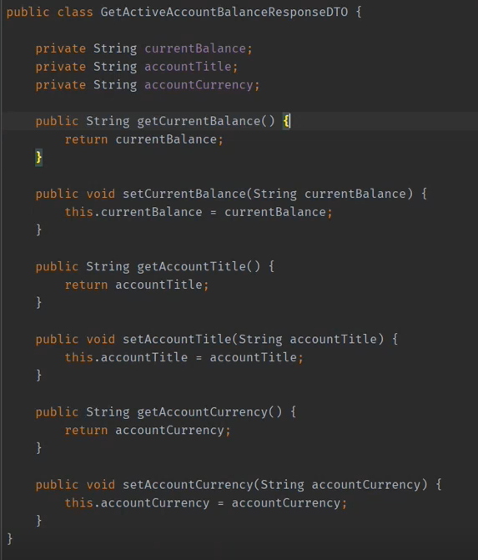

CCIMESSAGEADAPTER KO PARHNA HAI

Then yai response soap ki file mai add karna hoga

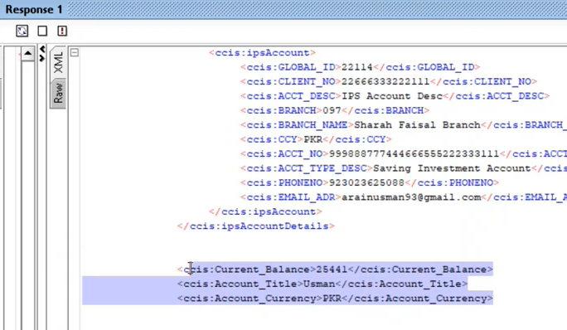

Ab Account resource mai jakar neechay sai code utha kar paste karengay us mai change karengay phr

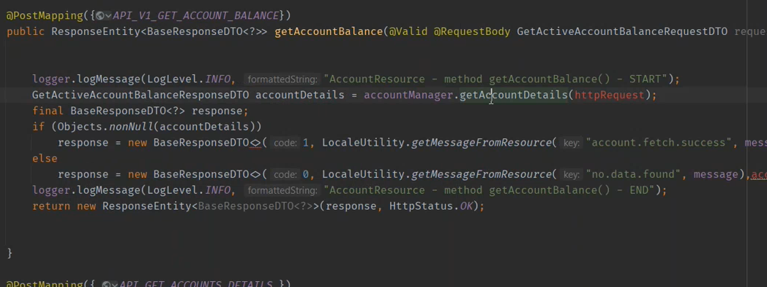

Then isi ki implementation class mai jakar method banayengay jo humay is account ki details lakar dega

AccountManager hai iski implementation class.

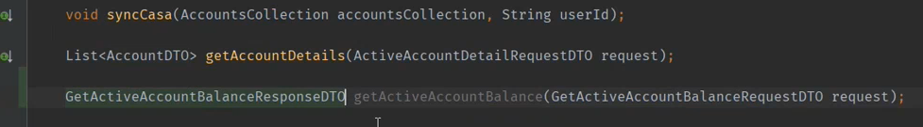

Phr iski implementation class mai isko implement karna hoga

Digital Manager hai iski implementation class

Alt + insert kar k umimplmented method implement karsaktay.

Phr rdv mai request jo jayegi us k liye map create karna hai

To wo 2 lines Casa waalay method sai copy karlengay

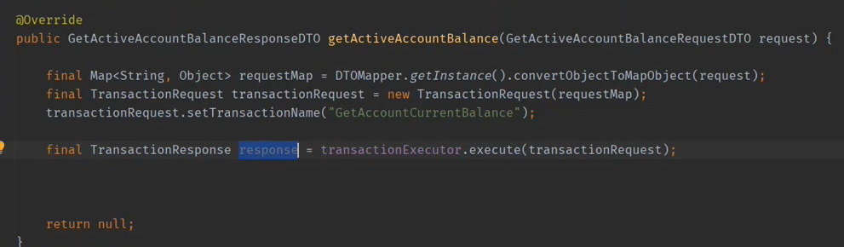

3RD Line ma jo transaction name dia hai wo unique hai transaction.xml file mai rakha hoga humne

Raast Management Impl sai code copy paste karsaktay

Raast Resource

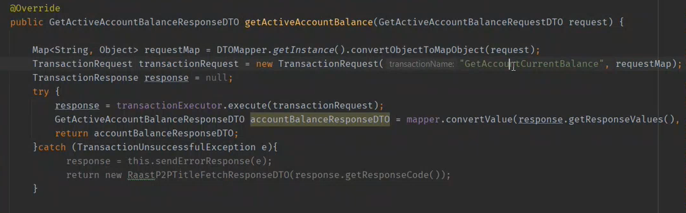

Object mapper parhna hai

